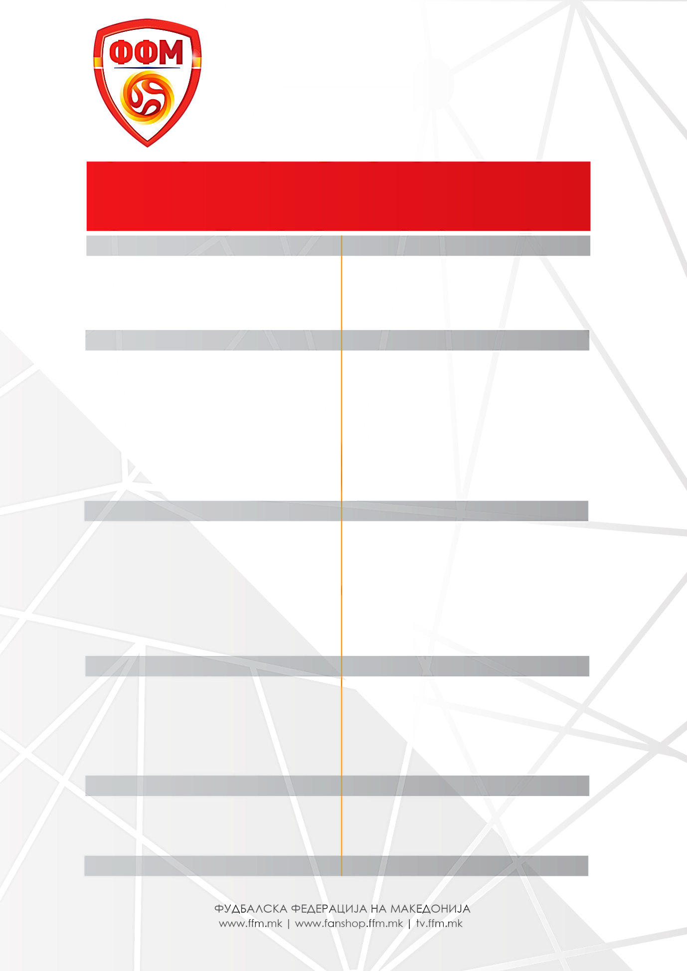

**GJIBRALTAR – MAQEDONI / MAQEDONI – ARMENI**

**6 shtator 2018 9 shtator 2018**

**GIMNASTIK Taragona** /Spanjë

**NORÇEPING** /Suedi

1. Stole **DIMITIREVSKI**
2. David **МITOV NILSON**
3. Arijan **ADEMI \***
4. Enis **BARDHI**
5. Stefan **SPIROVSKI**
6. Boban **NIKOLOV**
7. Ezgjan **АLIOSKI**
8. Elif **ELMAS**

**DINAMO Zagreb** / Kroaci

**LEVANTE** / Spanjë

**FERENCVAROSH** / Hungari

**MOL Vidi** / Hungari

**LIDS Junajted** / Angli

**FENERBAHÇE** / Turqi

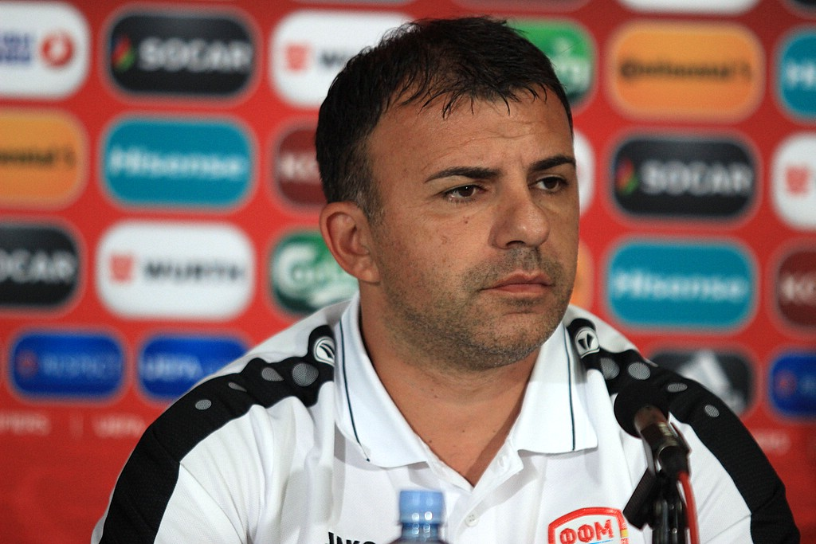Seleksionues:Igor **АNGELLOVSKI**

1. Goran **PANDEV**
2. Ilija **NESTOROVSKI**
3. Aleksandar **TRAJKOVSKI**
4. Ivan **ТRIÇKOVSKI**

**SPORTING Lisabon** / Portugali

**SHKËNDIJA** / Мaqedoni

**SHKËNDIJA** / Maqedoni

**VASHASH** / Hungari

**RIJEKA** / Kroaci

**JANINA** / Greqi

1. Stefan **RISTOVSKI**
2. Visar **МUSLIU**
3. Egzon **BEJTULLAI**
4. Kire **RISTEVSKI**
5. Darko **VELKOVSKI**
6. Мite **CIKARSKI**

**XHENOVA** /Itali

**PALERMO** /Itali

**PALERMO** / Itali

**AEK Larnаka** / Qipro