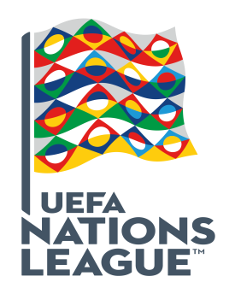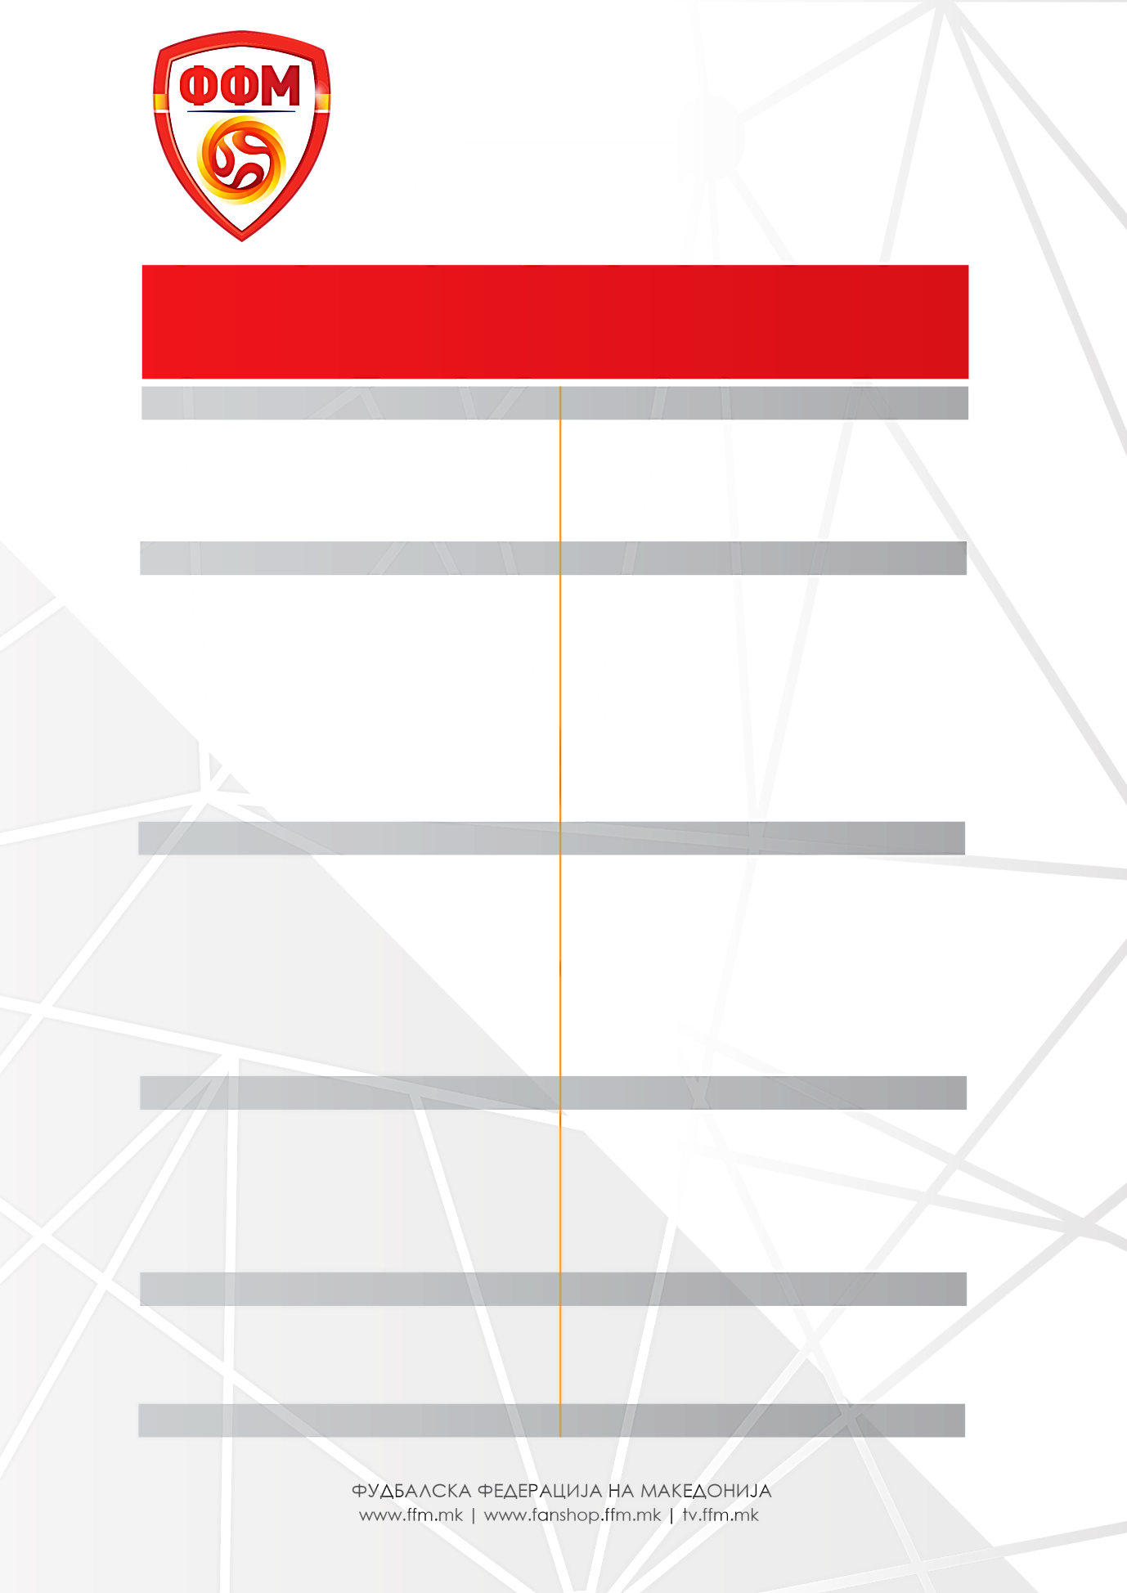

**MAQEDONI -** LIHTENSHTEJN / **MAQEDONI** – AREMENI

**13 tetor 2018 16 tetor 2018**

**GIMNASTIK Taragona** /Spanjë

**NORÇEPING** /Suedi

1. Stole **DIMITRIEVSKI**
2. David **MITOV NILSON**
3. Arijan **ADEMI \***
4. Enis **BARDHI**
5. Stefan **SPIROVSKI**
6. Boban **NIKOLOV**
7. Ezgjan **ALIOSKI**
8. Elif **ELMAS**

**DINAMO Zagreb** / Kroaci

**LEVANTE** / Spanjë

**FERENCVAROSH** / Hungari

**MOL Vidi** / Hungari

**LEEDS United** / Angli

**FENERBAHÇE** / Turqi

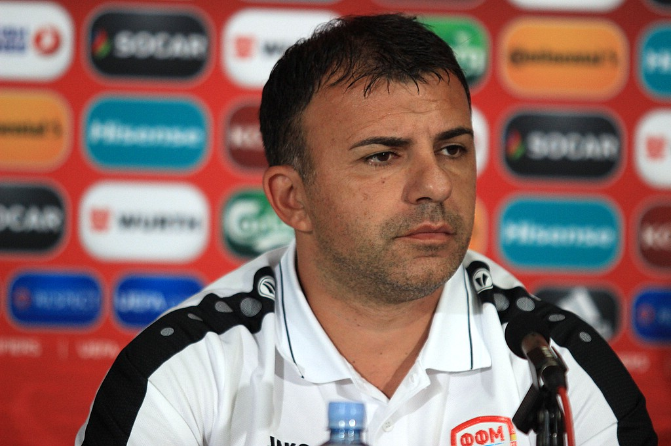Seleksionues:Igor **ANGELOVSKI**

1. Goran **PANDEV**
2. Ilija **NESTOROVSKI**
3. Aleksandar **TRAJKOVSKI**
4. Ivan **TRIÇKOVSKI**

**SPORTING Lisabon** / Portugali

**SHKËNDIJA** / Maqedoni

**SHKËNDIJA** / Maqedoni

**VASHASH** / Hungari

**RIEKA** / Kroaci

**JANINA** / Greqi

1. Stefan **RISTOVSKI**
2. Visar **MUSLIU**
3. Egzon **BEJTULLAI**
4. Kire **RISTEVSKI**
5. Darko **VELKOVSKI**
6. Mite **CIKARSKI**

**GENOA** /Itali

**PALERMO** /Itali

**PALERMO** / Itali

**AEK Laranka** / Qipro